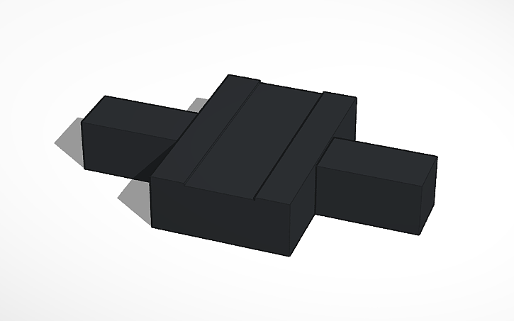

1



3

2

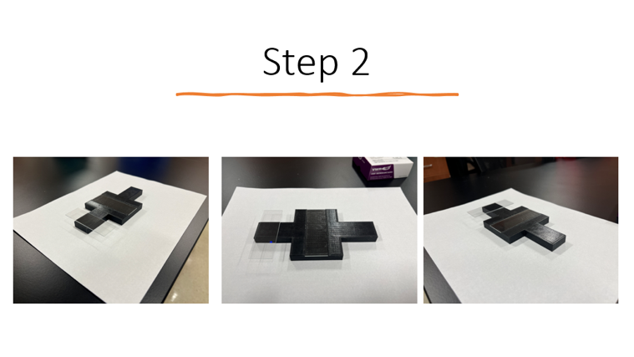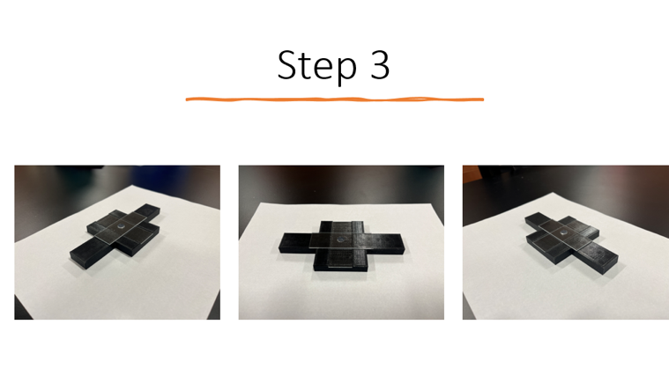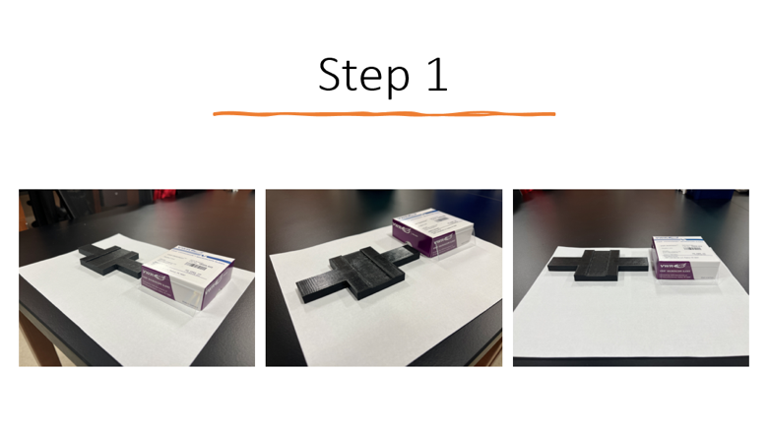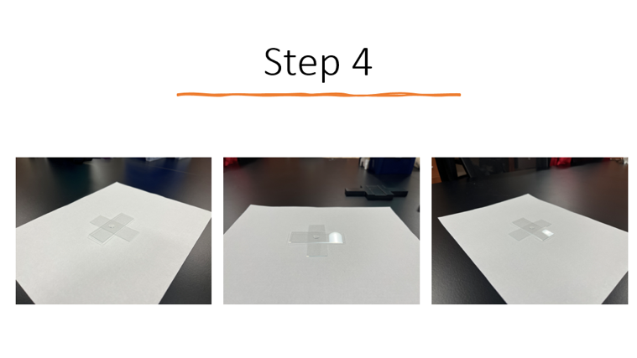

D

C

B

A

**Figure 1. 3D-schematic of the micropad-maker.**

The apparatus (**A**) features handles for easy pressing on the **red** stamping slide (**B**) for agarose pads, a central groove for inserting a standard microscope slide securely, and positions the stamping slide perpendicular to the **blue** micropad-mounting slide. (**C**) and (**D**) shows the device in the lab.

To create a micropad, 50-100 µl of 1-2% molten agarose solution is dispensed on the center of the **blue** micropad-mounting slide. As the agarose spot cools down, the **red** stamping slide is used to mold the nascent micropad. Duration of imaging is directly proportional to the percentage of agarose used (1-2%) to fabricate the micropad. Once the micropad can be slightly moved without structural disruption, the **red** stamping slide can be peeled off carefully but resolutely. To stage samples, cells or animals must be resuspended to optimal density for quality image capturing. A volume of 5-20 µl is recommended for most applications. Rotational dispersion of the sample with the coverslip is suggested to space out specimens. To do this, the coverslip is placed atop the sample diagonally from the corner. Afterward, the coverslip is pressed by a finger and rotated clockwise for either half or one complete turn. Density specifications will dictate the amount of rotation required. The micropad slide is allowed to equilibrate to imaging temperature conditions for 10-20 minutes, depending on the desired imaging length. Once equilibrated, the micropad slide is secured with VALAP solution along the edges of the coverslip.